2200031128 CH BHAVANA
WEEK 8 TASK 5
Objectives
- Explain how to clean up and push back to remote Git
In this hands-on lab, you will learn how to:
- Execute steps involving clean up and push back to remote Git.
Prerequisites
The following are the pre-requisites to complete this hands-on lab:
- Hands-on ID: “Git-T03-HOL_002”
Notes*:
Please follow the below steps for creating a free account in GitHub.
Do not use cognizant credentials to login to GitHub.

Estimated time to complete this lab: 10 minutes.
Please follow the instructions to complete the hands-on. Each instruction expects a command for the Git Bash.
- Verify if master is in clean state.
- List out all the available branches.
- Pull the remote git repository to the master
- Push the changes, which are pending from “Git-T03-HOL_002” to the remote repository.
- Observe if the changes are reflected in the remote repository.
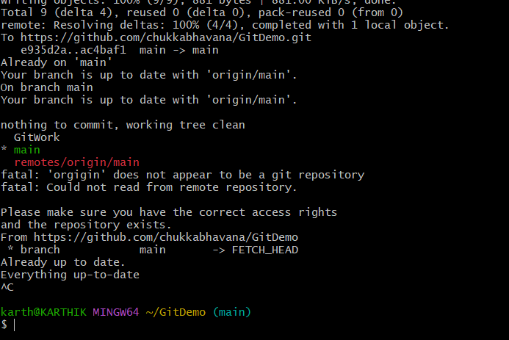
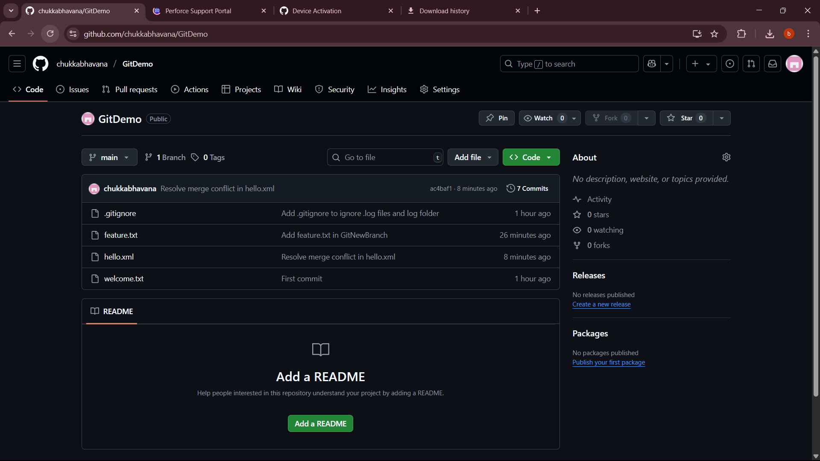

Clean up and Push Back to Remote in Git
1. Verifying the branch is clean
- Before pushing, ensure the working directory has no uncommitted changes.
- git status will tell you:
  - nothing to commit, working tree clean → ready to proceed.
  - If there are changes:
    - Commit them if you want them in the remote.
    - Or discard/reset if they are not needed.

2. Listing branches
- git branch -a shows:
  - Local branches — currently stored in your local repo.
  - Remote branches — tracked from the remote repository (origin).
- Helps confirm which branch you are on and what exists remotely.

3. Pulling from remote
- git pull origin main:
  - Fetches updates from the remote branch (origin/main).
  - Merges them into your current branch.
- Ensures your branch is up-to-date before pushing, avoiding non-fast-forward errors.

4. Pushing changes
- git push origin main:
  - Sends your local commits to the remote repository.
  - The remote branch is updated to match your local branch’s latest commit.
- If someone else also pushes to the same branch, you might need to pull and merge before pushing.

5. Verifying on the remote
- After pushing, check the remote repository (GitHub/GitLab) in a browser.
- The files and commit history should now match your local repository.

